Abigail Miller
Dr. Butler
DSC 140: Data Science Fundamentals
27 November 2025

Strava Analyses
Exercise apps such as Strava track detailed information about an athlete's performance including speed, elevation gain, distance, time, average pace, max pace, and the number of kudos (likes) an athlete receives. This data creates an opportunity to better understand an athlete's pattern of performance, how different workout characteristics relate to one another, and what factors influence engagement in activity posts. This report examines a data set of biking activities from a single Strava user named Pedro, the data set contains 40 columns and 1090 rows. Although the data set only focuses on one athlete, it contains a multitude of rides with consistent measurements, this can help to reduce variability and makes meaningful patterns easier to detect. For each ride the data set contains continuous variables such as, distance, moving time, total elevation gain, average speed, max speed, kudo count, and achievement count. The rides also include categorical variables such as work out type, and a created binary variable indicating whether max speed was faster or slower than the average max speed (created for classification).
The goal of this analysis it to analyze and answer three main questions using different statistics and machine-learning methods. The first question looks at if the number of kudos Pedro receives can be accurately predicted using the features distance, moving time, and total elevation gain, this will be evaluated using a regression neural network. The second question examines whether or not Pedro's speed can be accurately predicted to be faster or slower than his average max speed, using the features distance, moving time, total elevation gain, and achievement count. This will be evaluated using a decision tree which is a classification model. The final question looks at which factor has a stronger impact on Pedro's achievement count, total elevation gain or distance. This was evaluated using correlation analysis (Pearson and Spearman) and data visualization (scatter plots).
To predict the number of kudos Pedro would receive a regression neural network was used. A neural network is a machine learning model that mimics the function and structure of the human brain. These models consist of interconnected nodes also known as neurons which learn patterns and processes data, this enables tasks such as pattern recognition and decision-making, (GeeksforGeeks). To decide which features should be used to train with a correlation table and pair plot were created to display the relationships between kudos count and other numerical viables in the data set. Distance, moving time, and total elevation gain showed the strongest visible relationship and had the highest correlation score, making them the best candidates for training the regression model. The correlation scores were 0.663 for distance, 0.676 for moving time, and 0.665 for total elevation gain, these relationships are show below in Figure 1, Figure 2, and Figure 3.

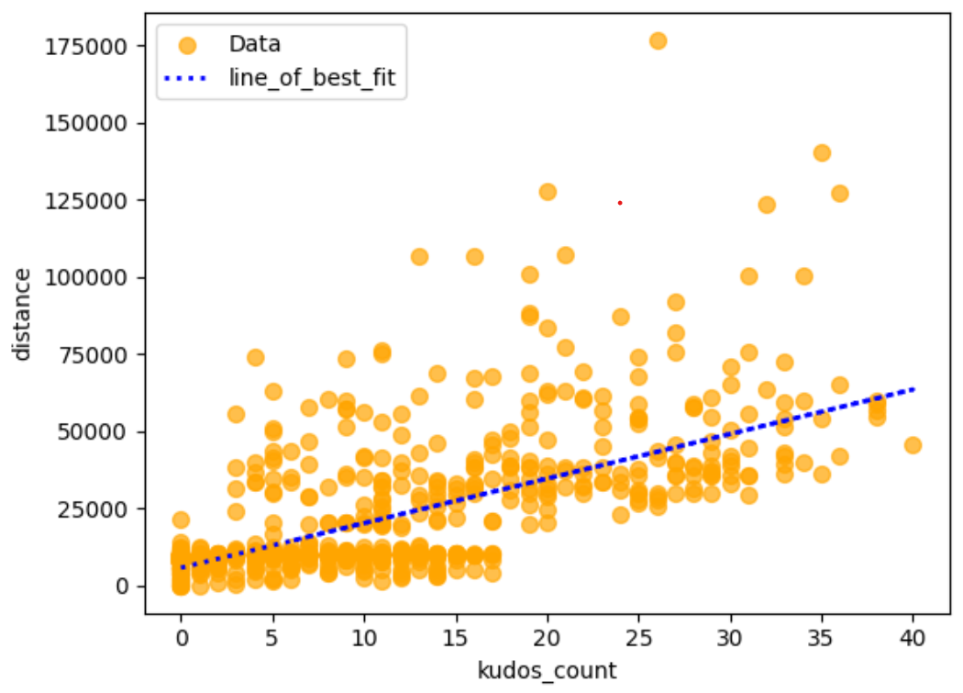
Figure 1: This graph shows the relationship between kudos count and the distance traveled. A line of best fit is shown.
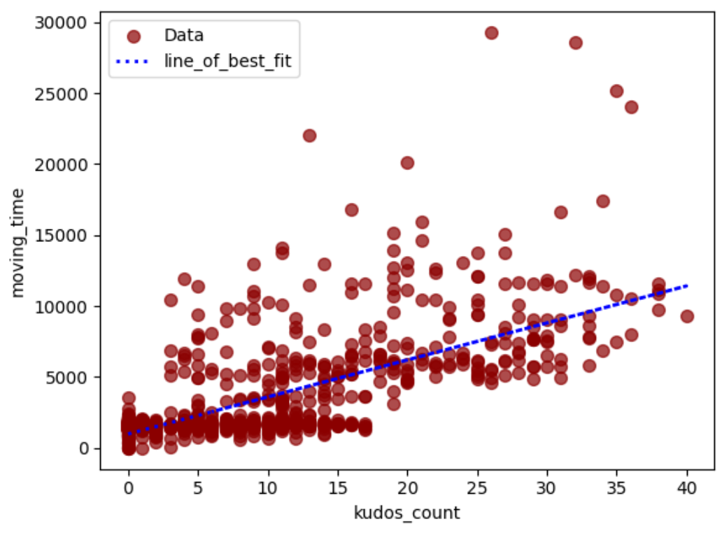
Figure 2: This graph shows the relationship between kudos count and moving time. A line of best fit is shown.

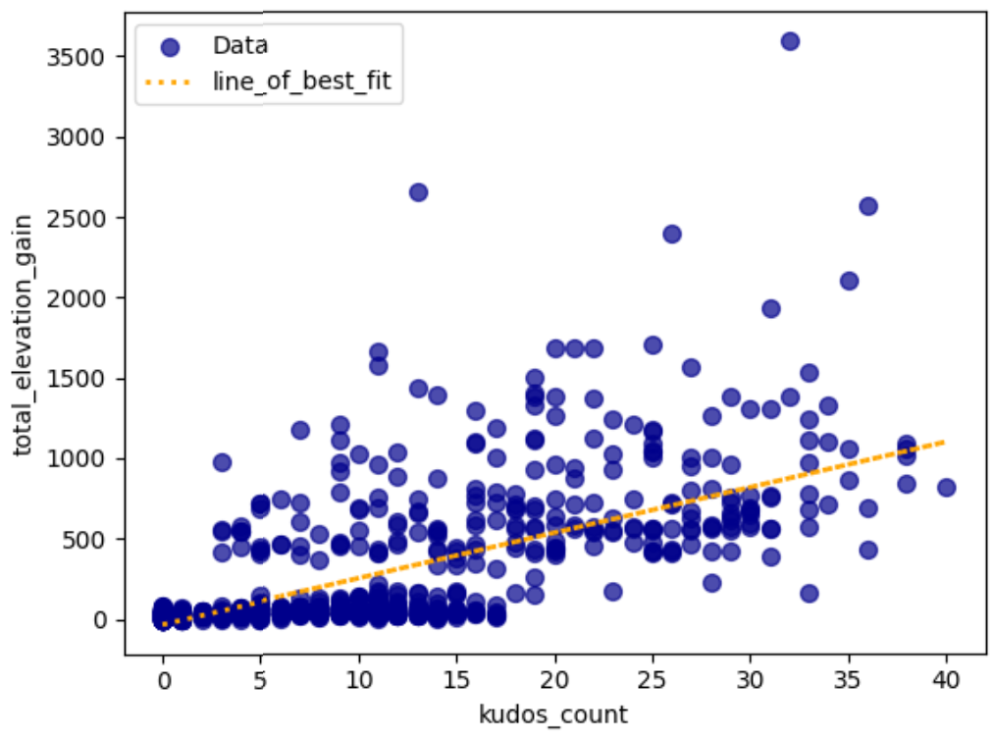
Figure 3: This graph shows the relationship between kudos count and total elevation gain. A line of best fit is shown.
The data was then divided into an 80% and 20% test and training split to prepare the data for model training. Then to determine the best hyperparameters for the regression neural network a grid search was used. A grid search will systematically evaluate all possible combinations of given parameters which are defined in a dictionary to identify the best performing parameters. The performance of the model during the grid search were evaluated and scored using an R^2 metric. The optimal parameters were found to be hidden layer sizes of [25, 25], the logistic activation function, and a maximum iteration limit of twenty-five hundred. Final testing was done over multiple tanning runs the best Root Mean Squared Error (RMSE) was found to be 5.572 and the predictions from this run are shown in the scatter plot below. The plot contains two sets of dots; the actual data values plotted on the x axis and the predicted values plotted on the y axis. Based on the results it can be concluded that the predicted data clusters more tightly than the true data especially at lower values. These results indicate that the neural network was not able to accurately capture any underlying relationships between kudos count and the selected features.
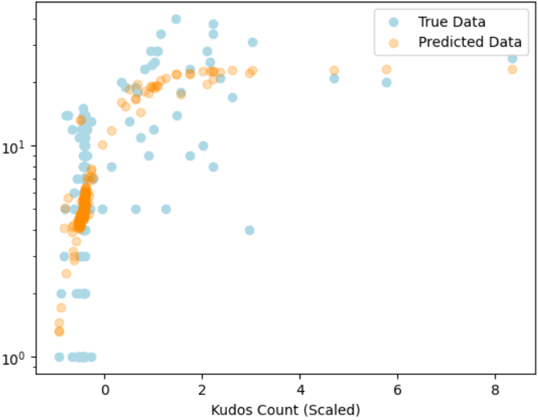
Figure 4: This graph shows the comparison between predicted data and true data, of Kudos Count. A key is shown on the right.
Figure 4 above shows that the neural network was able to make some correct predictions and follow over all trends, however there are many points that the predicted data deviates from significantly. Overall, the regression results demonstrate that kudos count cannot be reasonably predicted based on distance, moving time, and total elevation gain.
A classification decision tree clustering algorithm was used to determine if Pedro's maximum speed was faster or slower than his maximum average speed, using the features distance, moving time, total elevation gain, and achievement count. Before any testing was done, maximum speed was converted from numerical data to categorical data. This was done by first finding the average maximum speed, which was calculated to be 12.168. Then using code, a new column of data called speed_category was created by checking each of the values in the max speed column and assigning a 0 if the speed is less than or equal to 12.168, or a 1 if it is greater. Then to determine which features would be best to train with a correlation table and pair plot were used to display the relationship between speed category and other values in the data set. Distance, moving time, and total elevation gain showed the strongest visual relationships and had the highest correlation scores making them the best features to input into the decision tree. The correlation scores were 0.508 for distance, 0.466 for moving time, 0.493 for total elevation gain, and 0.390 for achievement count. With these features selected, the decision tree model could then be constructed.
A decision tree starts with a root node, which is a main question derived from the data sets features. After this, from the root, the decision tree will ask a series of true or false questions this will spit the data into different subsets based on specific attributes found in the data. A measure of impurity is used to determine the best split for each node, this is called a gini score. Then based on the answers the questions will lead to different branches, if the answer was true then the tree follows one path, if the answer is false the tree will follow a different path. The tree will continue branching through further decision making, this helps to reduce the data down step by step. This process will end when there are no questions left for the tree to ask, a leaf node will be created this is where the final decision or prediction is made, (GeeksforGeeks). Leaf nodes are typically considered perfect and only have one class, this can be concluded when the leaf has a gini score of zero or near zero. A full view of the structure of the decision tree after classifying the data can be seen below in Figure 5.
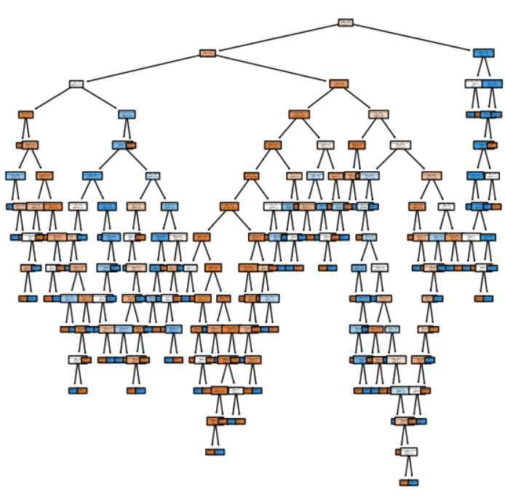
Figure 5: This graph shows the structure of a decision tree trying to classify max speed.
The next Figure 6 shown below is zoomed in on an end part of the structure to show what a leaf looks like as well as an idea of what a root node looks like. From the Figure 6 it can be seen that the leaves that no longer branch off have a gini score of 0.0 and the leaf that is still branching off has a gini score of 0.071.
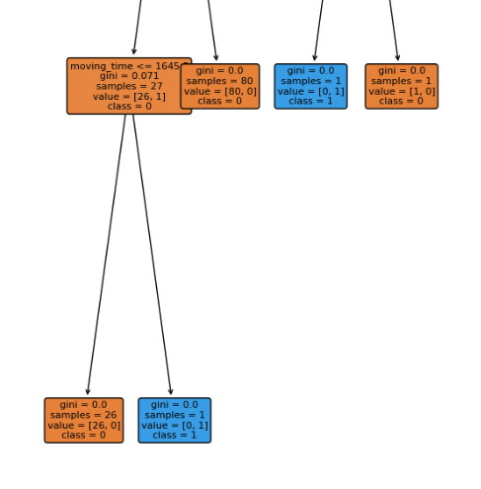
Figure 6: This graph shows a zoomed in part of the decision tree structure, gini scores can be seen.
The result of the decision tree was an accuracy of 85.4% meaning that the decision tree made the correct prediction 85.4% of the time. Based off of these results it can be reasonably concluded that where or not Pedro's maximum speed is higher or lower than average can be predicted using the features distance, moving time, total elevation gain, and achievement count.
To determine which features have more of an impact on achievement count, total elevation gain or distance, statistical analysis and data visualization were used. For statistical analysis Pearson correlation coefficients and Sperman R values were used. Pearson correlation coefficients is a statistical measure that quantifies the direction and strength of a linear relationship between two numerical variables, it's measured between 1 and -1, 0 meaning there is no correlation, (Turney). A Sperman R value measures monotonic relationships (variables move in the same direction, but not always at a constant rate), works with ranked data instead of raw values, it is also measured between 1 and -1. Instead of being in a straight line, the results will be on a curved line, (Statstutor). These measures measurements were used to test the relationships between achievement count and total elevation gain as well as achievement count and total distance. The results of this analysis are shown below in Figure 7.

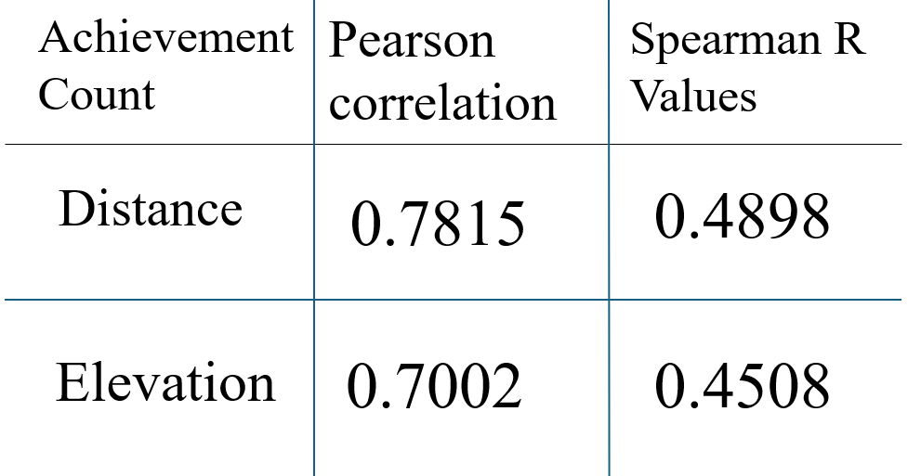
Figure 7: This graph shows the relationship between the variable's achievement count and distance and achievement count and elevation. Measured using Person correlation and sperman R values.
The table shown in Figure 7 helps to compare the results of the test to determine which feature has more of an impact on Achievement count. From From Figure 7 can be seen that total distance has both a higher Pearson correlation score and a higher Sperman score.
Scatter charts were used for the visual analysis of the relationships between these features and how they impact achievement count. In Figure 8 below the linear relationship between distance and achievement count can be seen.

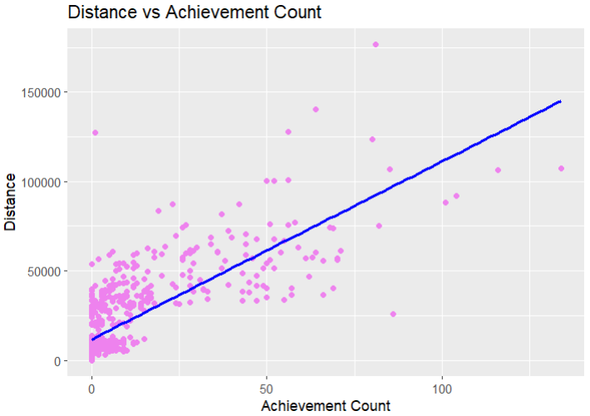
Figure 8: This graph shows the relationship between distance and achievement count. A line of best fit is shown.
It can be seen in Figure 8 that distance and achievement have a moderate positive correlation, with most points clustering toward the lower values in the plot shown in Figure 8, suggesting there is more data with low values than high values. The second graph below shown in Figure 9 is plotting the linear relationship between total elevation gain and achievement count.

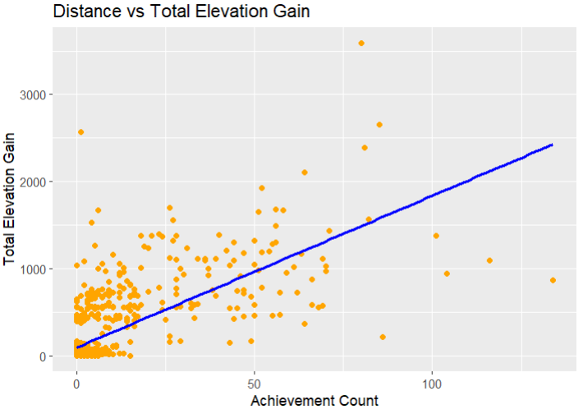
Figure 9: This graph shows the relationship between total elevation gain and achievement count. A line of best fit is shown.
It can be seen in Figure 9 that achievement count and total elevation gain also have a moderate positive correlation, with less points clustering toward the lower values in the plot. In Figure 9 it can be seen that the graph also appears to have more outliers than in Figure 8, suggesting it has a weaker correlation. From the results of the statistical and visual analysis it can be concluded that distance has more of an impact on achievement count than total elevation gain. Reasons for this could be that in Strava, longer activities activities naturally create more opportunities to earn achievements, there are more chances to set a personal record, and Strava awards distance badges.
This analysis examined 1,090 cycling activities from a single Strava user to explore factors influencing kudos count, speed classification, and achievement count. Results showed that a regression neural network using distance, moving time, and total elevation gain was not able to accurately predict kudos, indicating that social or contextual factors likely play a larger role in engagement. In contrast, a decision tree model was able to effectively classify rides as faster or slower than the average maximum speed with 85.4% accuracy, demonstrating that observable workout features can reliably predict performance outcomes. Statistical analysis and visual analysis reviled that distance has a stronger impact on achievement count than total elevation gain. Overall, these findings highlight both the potential and limitations of statical and machine-learning approaches in understanding fitness-tracking data and suggests that incorporation additional contextual or social variables could improve predictive accuracy and provide deeper insights into athlete engagement.

Works Cited
GeeksforGeeks. “Decision Tree.” GeeksforGeeks, 30 June 2025, https://www.geeksforgeeks.org/machine- learning/decision-tree/. Accessed 29 November 2025.
GeeksforGeeks. “What is a Neural Network?” GeeksforGeeks, 7 October 2025, https://www.geeksforgeeks.org/machine- learning/neural-networks-a-beginners-guide/. Accessed 29 November 2025.
J, Pedro. “Strava Activity Summary.” Kaggle, Kaggle, 2019, https://www.kaggle.com/datasets/pedrojunqueira/strava- activity-summary. Accessed 7 November 2025.
Scikit Learn. “1.10. Decision Trees — scikit-learn 1.7.2 documentation.” Scikit-learn, https://scikit- learn.org/stable/modules/tree.html#tree-classification. Accessed 30 November 2025.
Statstutor. “Spearman's correlation.” Statstutor, https://www.statstutor.ac.uk/resources/uploaded/spearmans.pdf. Accessed 29 November 2025.
Turney, Shaun. “Pearson Correlation Coefficient (r) | Guide & Examples.” Scribbr, 13 May 2022, https://www.scribbr.com/statistics/pearson-correlation-coefficient/. Accessed 29 November 2025.

